**About E-Krishi**

This Software Requirements Specification provides a complete description of all the functions and specifications E-Krishi.it is a full-site where Indian farmer are able to sell their agriculture crop products into different cities in there own price it is a platform that guides them which will help farmers from Indian villages to sell their agriculture product , took their crops for auctions to different cities on their on the other side wholesaler from town can also register and buy products as per their needs. With the help of this software people can easily submit their product. So all the processes of searching detail done very easily. From This process user can search all type of product related agriculture.

User can sell and purchase the crops easily and in a reasonable price.

There are three types of crops

About crop Kharif

The crops sown at the beginning of the south wes monsoon that is june jully every year are called kharif crops. These crops are harvested at end of the season September-october

About crop Rabi

The crops sown at the beginning of the south wes monsoon that is October-december every year are called kharif crops. These crops are harvested at end of the season March-April.

About crop Zaid

The crops grown on irrigated lands which do not have to wait for monsoons, in the short duration between Rabi and Kharif crop season, mainly from March to June, are called Zaid crops.

**Objectives**

* Preparation of a detailed database of the farmers and businessmen of the state Aggregation of responsive farmer community cultivating priority crops as determined by the market demand Enrolment of buyers in key markets including manufacturers Enrolment of agricultural input providers (seeds, plantlets, fertilizers, pesticides, technology/methodology providers/consultants, test laboratories and so on) and warehousing facility providers.
* Enrolment of logistics services support providers
* Enrolment of banks and insurers
* Establishment of a robust IT enabled platform where the members can seek information, transact and make or receive electronic payments

**Benefits to Member Farmers**

* Access to markets with prevailing price information and ensuring correct price for their products
* Access to schemes, subsidies, modern agricultural methods, best practices, soil testing, seeds, plantlets, fertilizers and pest control
* Facilities for grading agricultural produces
* Logistics support and cost sharing possibilities
* Access to micro credits
* Agri-insurance support/faster claim processing
* Access to accounting practices and documentation support

**Benefits to Member Agricultural Input Providers**

* Contact farmers producing any specific crop and confirm purchases in advance facilitating better control over supplies.
* Virtual aggregation of the produces.
* Buyer/exporters to post their pick-up quantities by date, by market-venue/warehouse.
* Plan logistics routes for collection of agri-produce in advance, seeing the offer from farmers in various locations.
* Select farmers for producing any specific variety of crops on contractual basis integrating supplies of seeds/plantlets, farm maintenance etc.
* Easy access to customers, facility for systematic campaigning/demonstrations.
* Efficient management of schemes/programs e-platform assisting in real time transactions.
* Searchable directory for all stakeholders with relevant details (contact persons, location, products/services offered, schemes & programs, territorial jurisdiction

etc.,) supported by robust platforms for communication, transaction and e-payments.

* Access to weather information and crop planning.

**The Vision and Mission of the Project**

The vision of the project is to establish a connected farmers’ community throughout india who have access to information on market demand, prices, good agricultural practices, quality agricultural inputs supported by a technology enabled robust transaction platform that facilitates all their offline activities. The project addresses the existing gap in agriculture information flow and transaction management.

**For society**

e-Krishi Portal The project e-Krishi relies heavily on the portal (www.e-krishi.org) developed for the purpose. The features of the portal include a home page with a lot of other menus useful for the purpose. It contains information about farm advisory services, resource library, agricultural market information etc. Trade takes through the Trade Centre Corner where the sellers as well as buyers can register themselves. The sellers (farmers) and buyers (merchants) register through the nearest Akshaya Centre or log on to www.e-krishi.org. They post the materials for selling/buying. The buyers and sellers post and view advertisements and in the final stage virtual meeting of buyer and sellers through the web effecting transaction is the substance of the e-Krishi project. A toll free Call Centre (1800-425-1661) is also functional with the aim of helping farmers and buyers in solving trade related doubts and providing details on good agricultural practices including local weather. It is being managed by qualified agricultural specialists. A view of the home page of the e-krishi portal is provided here for the reference of readers

**How it functions**

* Sellers (farmers) and buyers (merchants) register through nearest Akshaya Centre or log on to [www.e-krishi.org](http://www.e-krishi.org/)
* Post the materials for selling/buying
* Post and view advertisements
* Virtual meeting of buyer and sellers through the web and effect transaction

**TOOLS /PLATFORM APPLICATION USED**

**2.1. Hardware Configurations:**

Processor : Pentium 4, higher version

RAM : 512 MB

Hard Disk : 40 GB space

**2.2.Software Configurations:**

Operating System : windows 2000, xp ,vista , windows7

Web Server : Xamp

Technology : PHP

Backend : mysql

Scripting language : php

Web Design : HTML, HTML5, CSS

**Data Flow Diagram**

A data flow diagram (DFD) is a graphical representation of the "flow" of data through an information system . DFDs can also be used for the visualization of data processing (structured design).

On a DFD, data items flow from an external data source or an internal data store to an internal data store or an external data sink, via an internal process.

A DFD provides no information about the timing of processes, or about whether processes will operate in sequence or in parallel. It is therefore quite different from a flowchart, which shows the flow of control through an algorithm, allowing a reader to determine what operations will be performed, in what order, and under what circumstances, but not what kinds of data will be input to and output from the system, nor where the data will come from and go to, nor where the data will be stored (all of which are shown on a DFD

**Symbols of DFD**

Data process 

Data flow

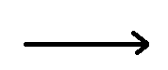

Data store

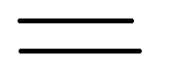

Source / sink



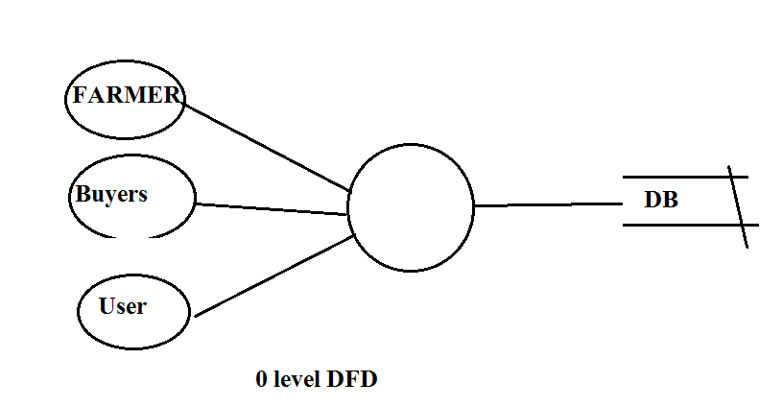

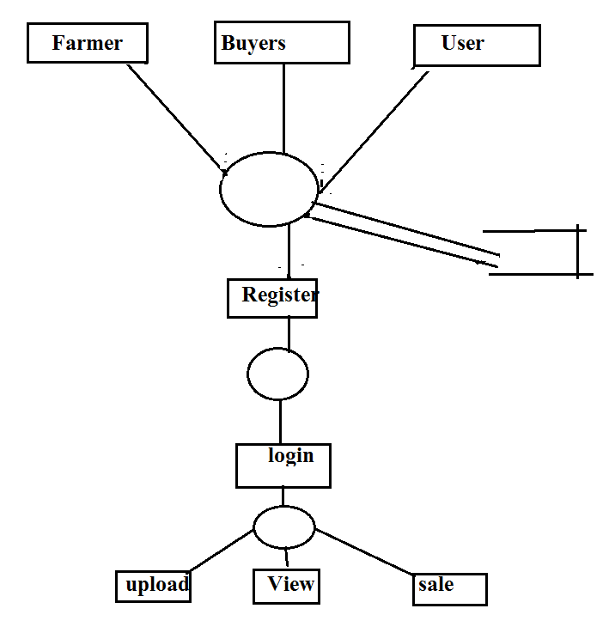

**ER- Diagram**

Definition: An entity-relationship (ER) diagram is a specialized graphic that illustrates the interrelationships between entities in a database. ER diagrams often use symbols to represent three different types of information. Boxes are commonly used to represent entities. Diamonds are normally used to represent relationships and ovals are used to represent attributes.

Also Known As: ER Diagram, E-R Diagram, entity-relationship model

### Entity Relationship Diagram Notations

Peter Chen developed ERDs in 1976. Since then Charles Bachman and James Martin have added some sligh refinements to the basic ERD principles.

##### Entity

An entity is an object or concept about which you want to store information.  
Learn how to edit text on an entity.

Entity

##### Weak Entity

A weak entity is an entity that must defined by a foreign key relationship with another entity as it cannot be uniquely identified by its own attributes alone.  
Learn how to edit text on this object.

Weak Entity

##### Key attribute

A key attribute is the unique, distinguishing characteristic of the entity. For example, an employee's social security number might be the employee's key attribute.

Key attribute

##### Multivalued attribute

A multivalued attribute can have more than one value. For example, an employee entity can have multiple skill values.

Multivalued attribute

##### Derived attribute

A derived attribute is based on another attribute. For example, an employee's monthly salary is based on the employee's annual salary.

Derived attribute

##### Relationships

Relationships illustrate how two entities share information in the database structure.

Learn how to draw relationships:  
First, connect the two entities, then drop the relationship notation on the line

